Practice for Lesson 7: Siebel Component, Groups and Applications

Practices for Lesson 7

Overview

In these practices, we will explore the Siebel Enterprise, Servers, Component Groups and Components.

Practice 7-1: Explore, define and configure Siebel Component Groups

**Overview**   
In this practice you will enable a component and disable a component group. Further, will explore the Siebel Enterprise, Servers, Component Groups, and Components.

Assumptions

You should have completed the Practices of Lesson 3.

Tasks

1. You will access the main menu by clicking the menu icon

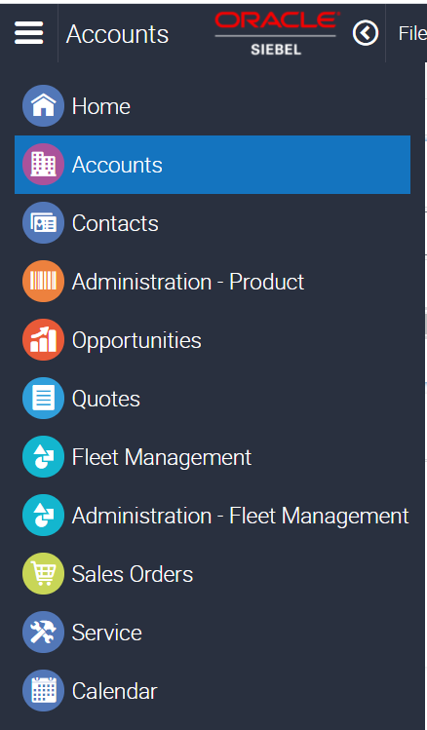

1. Access the **Administration – Sever Configuration** from the site map

1. Starting Siebel Call Center Web Client
2. Open the browser (Google Chrome/Firefox).
3. Enter Siebel URL web Client (https://public-ip-address:4430/siebel/app/sales/enu)
4. Enter: User ID – SADMIN and Password - XXXX
5. Click **Login.**
6. Exploring Siebel Components
7. Navigate to the Site Map.
8. Click **Administration – Server management.** You will see the current state of your servers.
9. Under Servers, click **Component Groups.**

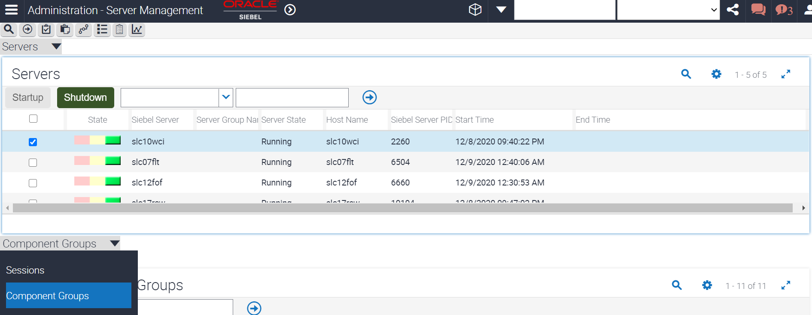

1. You will see one Siebel Server listed.
2. Verify that the Siebel Server is running. This is the name of your Siebel Server.
3. In the middle applet, the currently enabled component groups are displayed along with their state.

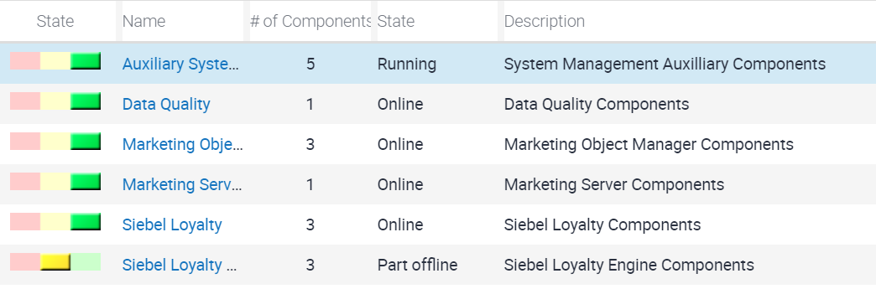

1. Exploring Sessions
2. In the middle (Server Component Groups) applet, in the view tabs, **click Sessions.**

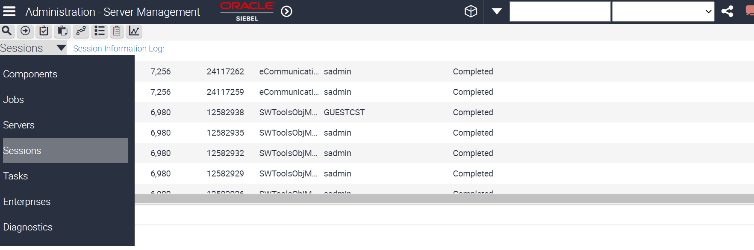

1. At the top of the list applet, verify that you see a session with **Component = ServerMgr**. That represents the server manager screens you are currently viewing.
2. In the list applet, verify that you see a session with Component = SCCObjMgr_enu, OM Login = SADMIN, and State = Running. That represents you are currently logged in into the Call Center application.

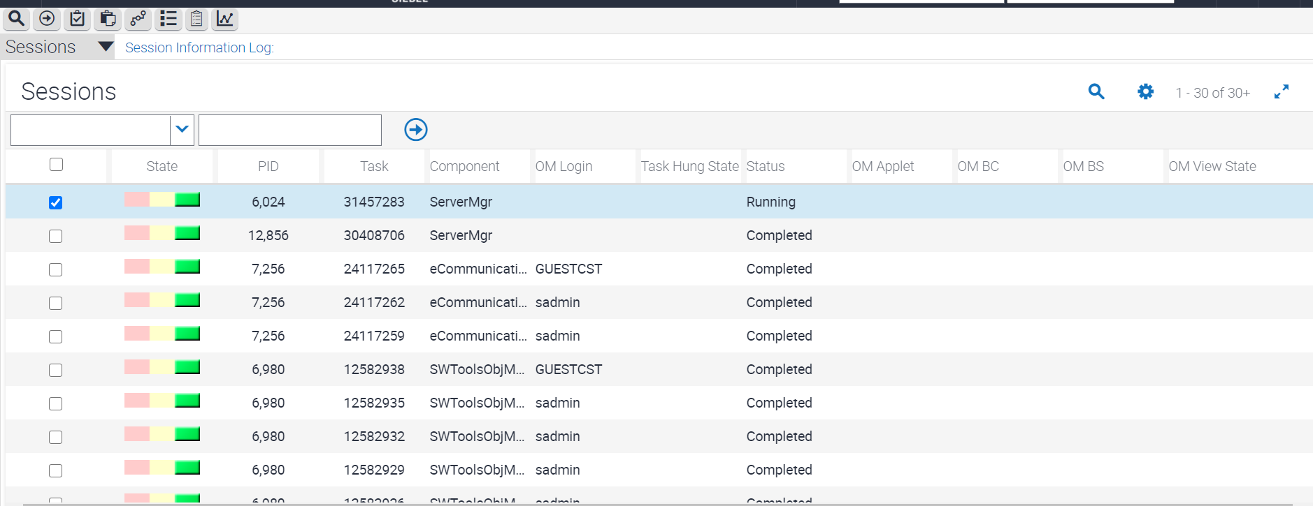

1. Exploring the Siebel Enterprise.
2. In the link bar (at the top), **click Enterprises**

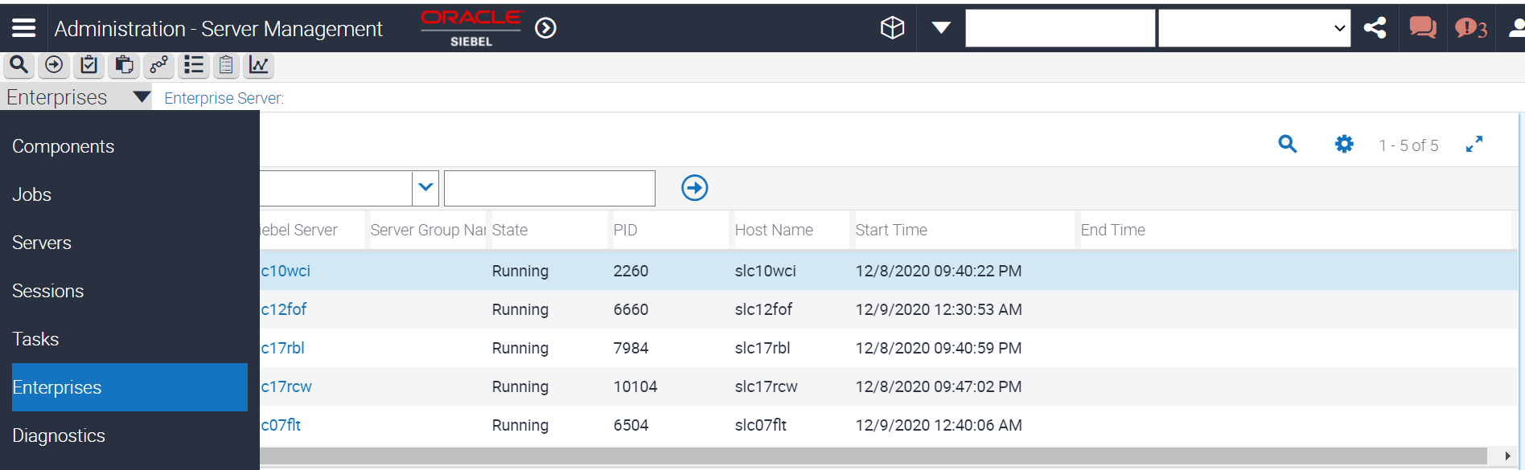

1. Verify that the top applet displays **the Enterprise Server.**
2. Notice that Enterprise Server. This is the name of your enterprise.
3. Verify that the middle applet displays the Siebel Servers.
4. You will see that the bottom applet, displays components assigned to the selected server. This is an alternate way to view the component information.
5. Enabling a component
6. Navigate to **Site Map.**
7. Click **Administration - Server Management**. This view allows you to modify settings.

1. Click **Enterprise Explorer**. This displays an explorer view.  
   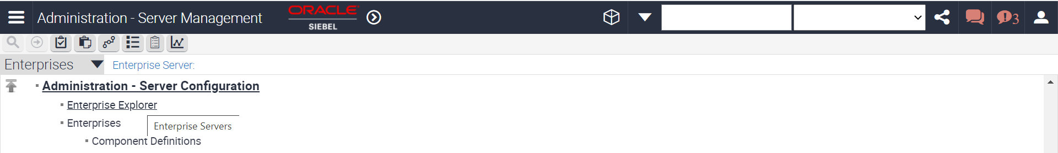
2. In the left pane, **expand the server.**
3. In the left pane, **expand Component Groups.**
4. In the right pane in the list applet, you will see the Name as well as the Alias for the component group is displayed.
5. Query for the **record with Alias = Sales.**
6. You will see the **Enable state = Enabled**.
7. This means that the component is enabled for the enterprise and available to the Siebel Servers to run.
8. In the link bar, click **Servers.**

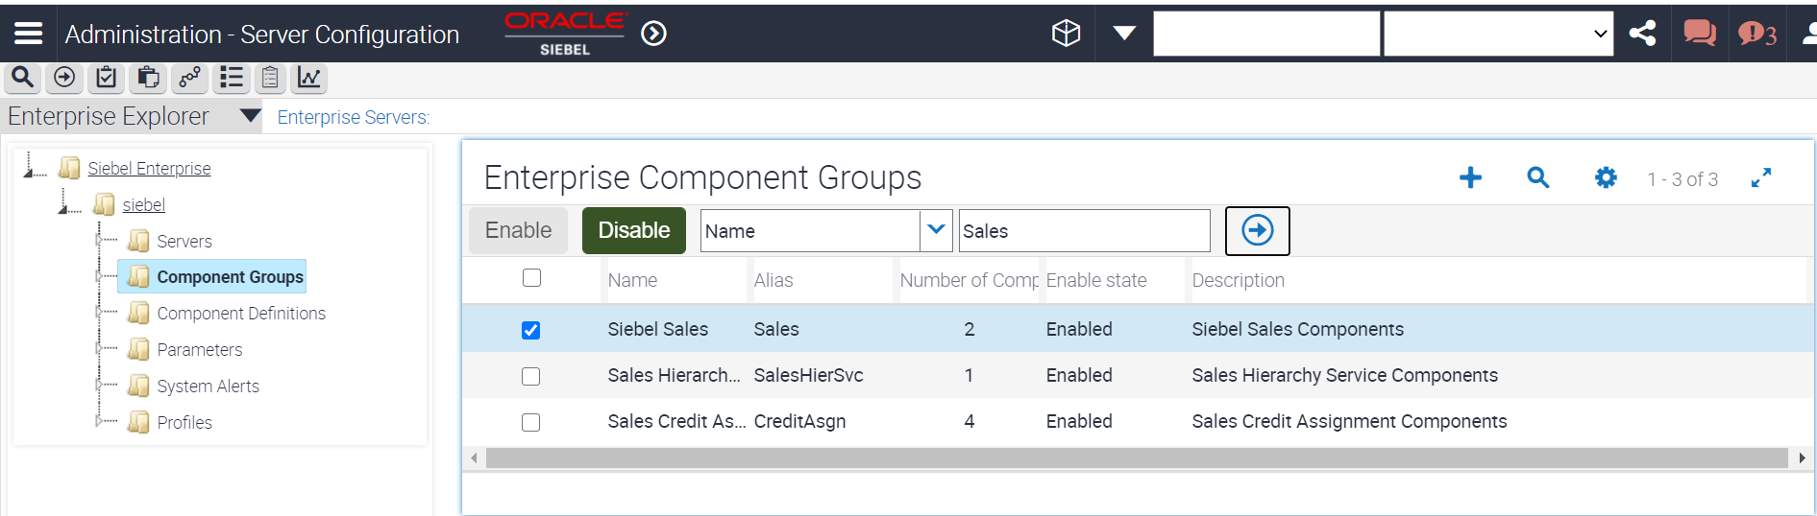

1. Disabling a component group.
2. In the view tabs at the top, **select Enterprises.**
3. In the Enterprise **Component Groups applet**, select the record with Alias = HandheldSyncSIS.  
   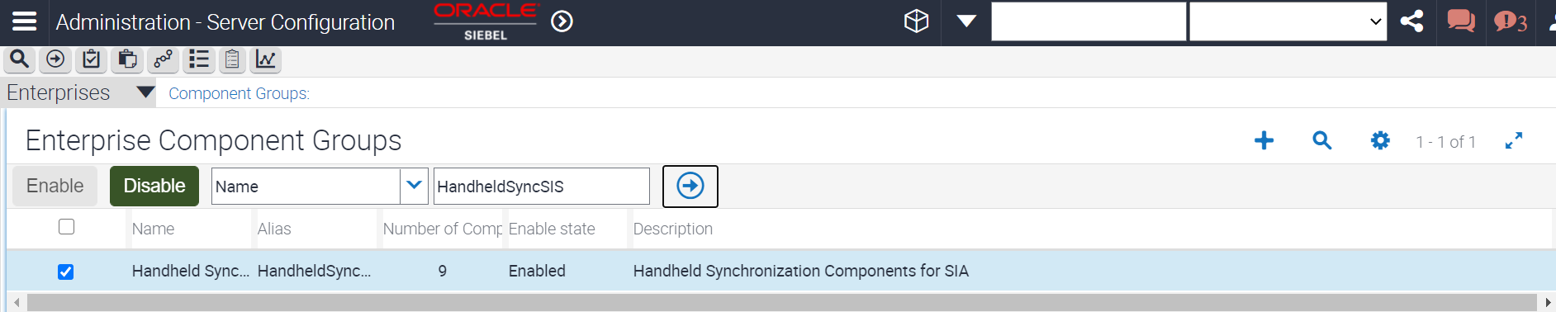
4. Click **Disable** to disable this component group for the enterprise.
5. In the Enterprise Component Groups applet, **Query for Enable state = Disabled.**
6. Verify that HandheldSyncSIS is in the list.
7. Verifying your changes
8. Navigate to Site map - **Administration - Server Management > Servers > Component Groups.**

1. Select the component group named **Siebel Sales.**

1. Verify its state.
2. In the bottom applet, verify that the **Component = Sales Object Manager (ENU)** is now Online.
3. Navigate to **Administration - Server Configuration > Enterprises > Component Groups**.
4. In the Component Groups applet, query for **Enable state = Disabled**.

1. In the bottom right (Component Group Assignments) applet, notice that the Assign, Enable, and Disable buttons are not active. When a component group is disabled for the enterprise, it is not available to any of the Siebel Servers to run.